Optional 36_marea_operations_deployment.csv
May 26, 2026

Definition of the Input File

VisionEval (https://visioneval.github.io/docs/model-inputs.html) explains that this optional file is used to specify the proportion of DVMT affected by operations for different road classes. The file is used in the Initialize (VETravelPerformance) and CalculateRoadPerformance modules. The file has six attributes which specify the proportion of freeway DVMT affected by ramp meeting or incident management, the proportion of arterial DVMT affected by signal coordination or access management, and the proportion of freeway or arterial DVMT affected by other “user-defined … operations measures.” For example, the table below suggests that for Albemarle and Charlottesville, there is no ramp metering, about half the DVMT (on interstates) is affected by incident management, about half the DVMT (on arterials) is affected by signal coordination for 2024 and 2045. Between 2024 and 2045, however, the DMVT affected by access management is forecast to increase from 10% to 20%.

Possible Scenario

The document Task 7.2 Simplified Scenario Development guide available at A Playbook for Simplified Approaches for Creating Scenarios in VisionEval clarifies that three files may be used in to quantify “changes in policy and physical interventions to improve congestion through improved speed management and reduced delays.” This particular file can thus help one evaluate scenarios such as using signal coordination to improve traffic flow (and logically one could compare such operations experiences with the results from a capacity expansion that results from, say adding lane miles. The other two files that relate to operations are marea_speed_smooth_ecodrive.csv and other_ops_effectiveness.csv.

Method Used for Virginia

Three main steps were used to develop these values, with 2024 and 2045 values being identical except, as noted in step 3.4.5, the proportion of the statewide network subject to access management is believed to be 10% in 2024 and 20% in 2045. As is the case with all input values, the user can adjust these assumptions.

- Source: 2023 ITS Deployment Tracking Survey, ITS Deployment Evaluation, U.S. DOT
  - URL: https://www.itskrs.its.dot.gov/deployment/2023DTS
  - Location: Deployment Statistics – 2023 ITS Deployment Tracking Survey
  - Search Keyword: Not Applicable
  - Related Sheet: Not Applicable

- Year that the Data Reflect: 2023 (Substituted for 2024 based on the assumption that year-to-year differences are negligible)

- How the Data Were Processed
  - RampMeterDeployProp
    - According to the 2023 Freeway Management Deployment Data (XLSX), only District 9 reported having implemented ramp metering. However, the survey does not provide the number of ramps deployed. Therefore, a 5% deployment rate was assumed for counties/cities in District 9 (Counties: Arlington, Fairfax, Loudoun, Prince William / Cities: Alexandria, Fairfax, Falls Church, Manassas, Manassas Park), reflecting a limited implementation. The target year values were set equal to the base year due to the lack of public data on future deployment plans. These values may be revised at the analyst’s discretion based on regional characteristics.
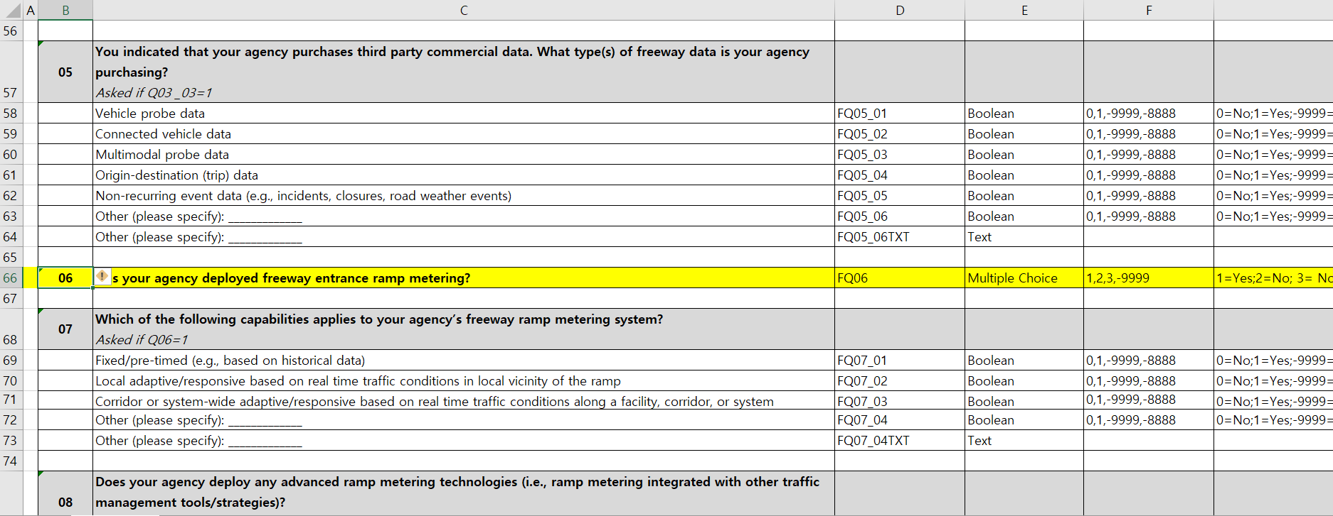
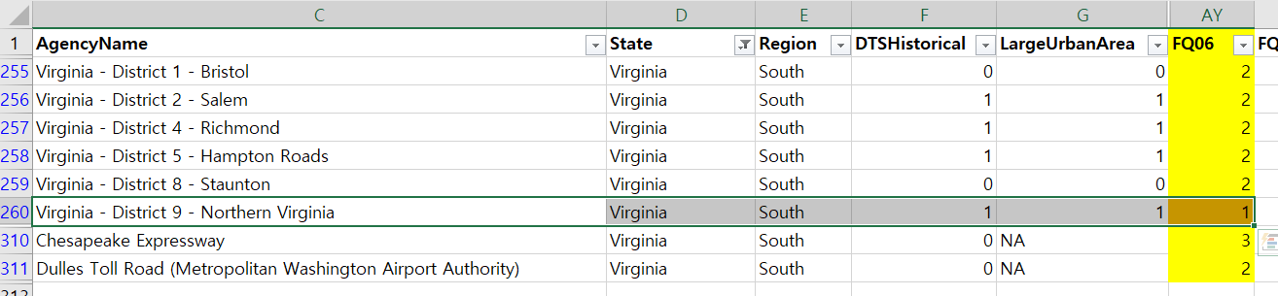
  - IncidentMgtDeployProp
    - According to the 2023 Freeway Management Deployment Data (XLSX) and 2023 Arterial Management Deployment Data (State DOT District) (XLSX), all districts reported the use of incident detection and verification methods on both freeways and arterials. However, the survey does not specify the extent of deployment. Therefore, a 50% deployment rate was assumed for all counties and cities. This rate is consistent with the Sayed model and appears to be a reasonable assumption in the absence of more detailed data. The target year values were set equal to the base year due to the lack of public data on future plans. These values may be revised at the analyst’s discretion based on regional characteristics.
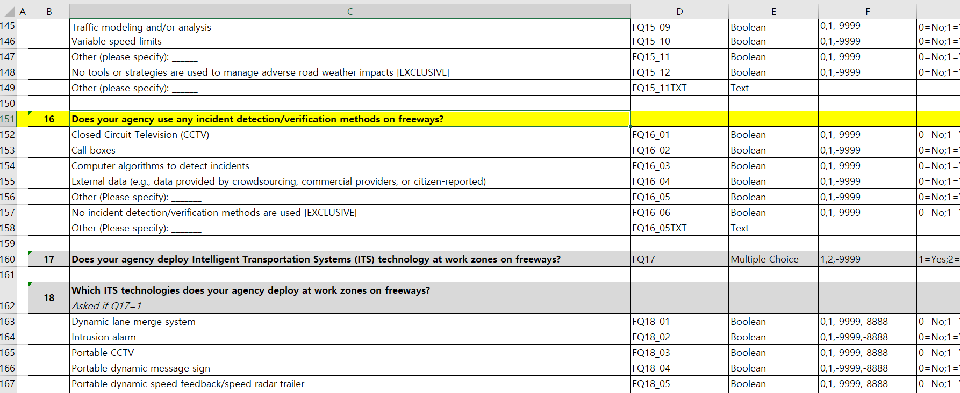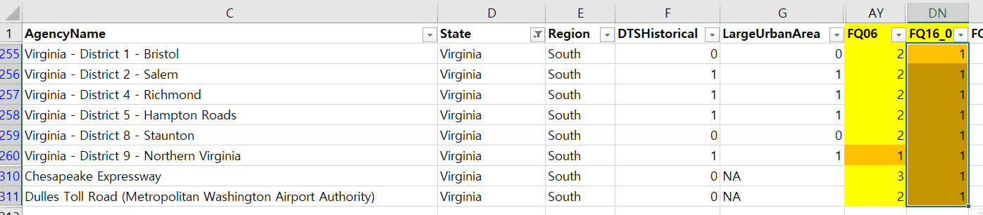
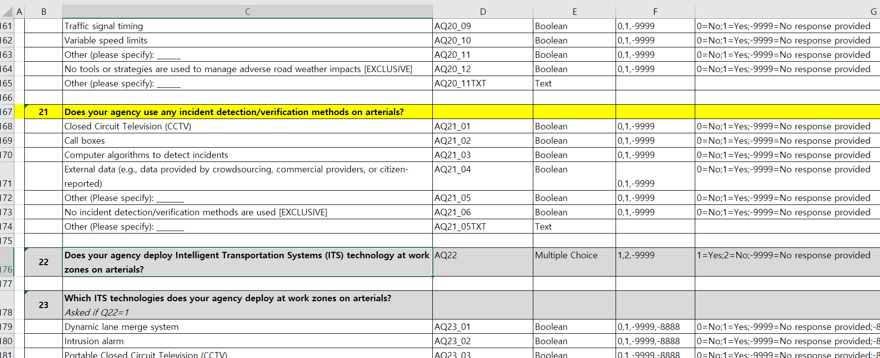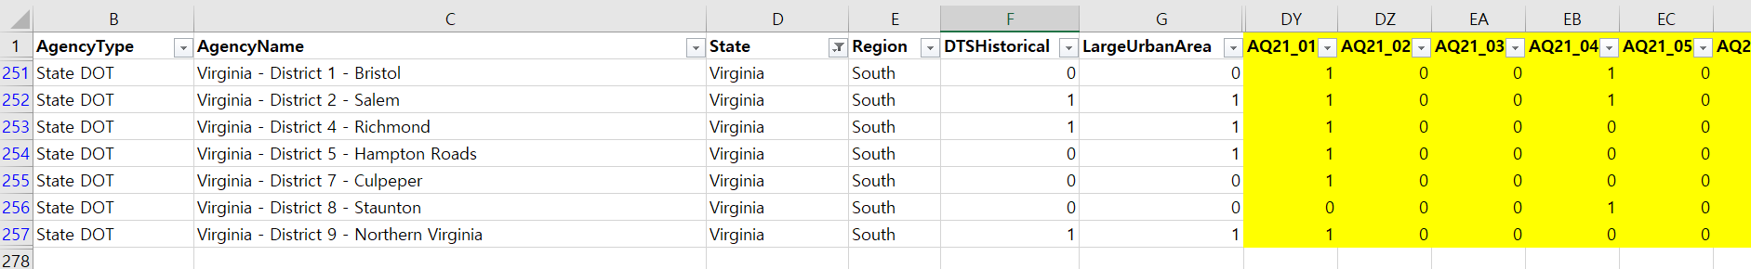

  - SignalCoordDeployProp
    - No public data sources are available; therefore, a 50% deployment rate was assumed for all counties and cities. This rate is consistent with the Sayed model and appears to be a reasonable assumption in the absence of more detailed data. The target year values were set equal to the base year due to the lack of public data on future plans. These values may be revised at the analyst’s discretion based on regional characteristics.
  - AccessMgtDeployProp
    - Access management regulations were formally adopted by VDOT in 2008 (amended in 2011) through the Virginia Administrative Code (24VAC30-73) and the Road Design Manual (Appendix F). These regulations mandate entrance spacing, intersection spacing, and median opening standards for new and redeveloped roadway projects. However, because the vast majority of arterial corridors were constructed prior to 2008, only a limited portion of the network has been retrofitted to meet the new standards. As a result, it is reasonable to assume that approximately 10 percent of arterial roadway mileage is subject to access management practices in the 2024 base year. Looking ahead, as more corridors are reconstructed or upgraded under VDOT’s long-range plans, the share of arterials with access management is expected to expand gradually. Therefore, for the 2045 target year, this analysis assumes the proportion will approximately double to 20 percent of the statewide arterial network.

  - OtherFwyOpsDeployProp, OtherArtOpsDeployProp
    - No public data sources are available; therefore, a 0% deployment rate was assumed for all counties and cities. This rate is consistent with the Sayed model. The target year values were set equal to the base year due to the lack of public data on future plans. These values may be revised at the analyst’s discretion based on regional characteristics.

  - Final Result
